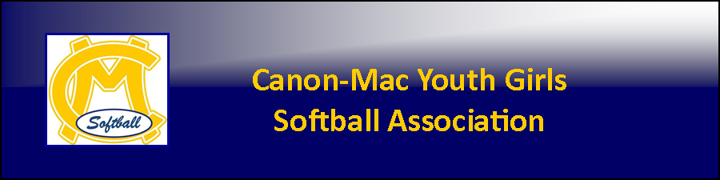

CODE OF CONDUCT

As a member of the Canon-Mac Youth Girls Softball Association (or CMYGSA), I hereby pledge to provide positive support, care and encouragement to any member of the CMYGSA participating in any event on behalf of the organization by following this Code of Conduct:

- Members include, but are not limited to, players, parents, fans, coaches, board members, officials, opposing team players, opposing team parents, opposing team fans, opposing team coaches, opposing team board members, and anyone that is involved in the CMYGSA or a CMYGSA event.
- I will demonstrate ethical core values, at all times, during practice and games, which include caring, honesty, respect and responsibility to all members and never act in a manner that would be disrespectful toward them.
- I will not use drugs, alcohol or tobacco while in contact with any member during any CMYGSA event or on any property that the CMYGSA is using.
- I will not criticize any member in relation to a CMYGSA event.
- I will accept the decision of the officials as being fair.
- I will keep all sports environments safe and clean at all times and follow all property and CMYGSA policies and procedures during the use of facilities.
- I will not jeopardize a player’s health by allowing her to enter or re-enter a competition once she is injured.
- I will always be alert for any signs that would indicate an injury or a safety hazard.
- I will ensure that my actions and activities serve as a foundation for life learning and are structured to help the members achieve their potential in spirit, mind and body.
- I will emphasize “teamwork” and playing as a team.
- I will display good sportsmanship ahead of my own personal desire to win.
- I will follow any and all league or competition rules.
- I will always exemplify and demonstrate fair play regardless of the score by acting in a positive manner towards all members.
- I will refrain from using abusive and profane language toward any member.
- I will remember that games are played for fun.
- If I am a member of a competition, I will shake hands with the opposing members at the conclusion of the competition.
- Should a concern about a member arise, I will contact a CMYGSA Board Member.
- I understand that I will be suspended from the association for violation of this Code of Conduct.

