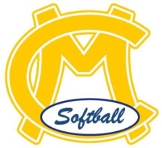
Big Sister / Little Sister Program

- Big Sister Team is matched up with a Little Sister Team.
- The big sisters will create hair bows for themselves and their little sister!
- The Big Sister Team will be taught the Every Days or how to teach how to throw by the Director of Development and then they will in turn run a practice for their Little Sister Team teaching them the same things!
- The Big Sister Team should attend a game to watch their Little Sisters!
- The Little Sister Team should attend a game to watch their Big Sisters!

BENEFITS
- Big Sisters can develop leadership skills!
- Big Sisters can learn to understand the skills better because they then become the teacher!
- Builds community spirit within the CMYGSA!
- Builds self-esteem for the Little Sisters and makes them feel special!

